

DATABASE MANAGEMENT SYSTEM (ENCS205)
Lab Report Submitted to

K. R. Mangalam University
for

Bachelor of Technology in
Computer Science and Engineering Submitted by

YASHIETA SETHI [2401010187]

Course Teacher MISS MANSI KAJAL

School of Engineering & Technology

K. R. MANGALAM UNIVERSITY
Sohna, Haryana 122103, India Jan-2026

Table of Contents
Exp  . No | Name of the Experiments | Date of Experiment | Date of Submission | Faculty Signature
1 | To design an Entity Relationship (ER) diagram for the College  database and convert the ER diagram into relational tables.
2 | To design an Entity Relationship (ER) diagram for the Company  database and convert it into relational  tables.
3 | To design and implement a Customer–Sale database schema using SQL by creating tables with integrity constraints, inserting records, and performing queries and views to retrieve sales and customer information
4
5
6
7
8

Experiment No: 1

Aim:
To design an Entity Relationship (ER) diagram for the College database and convert the ER diagram into relational tables.

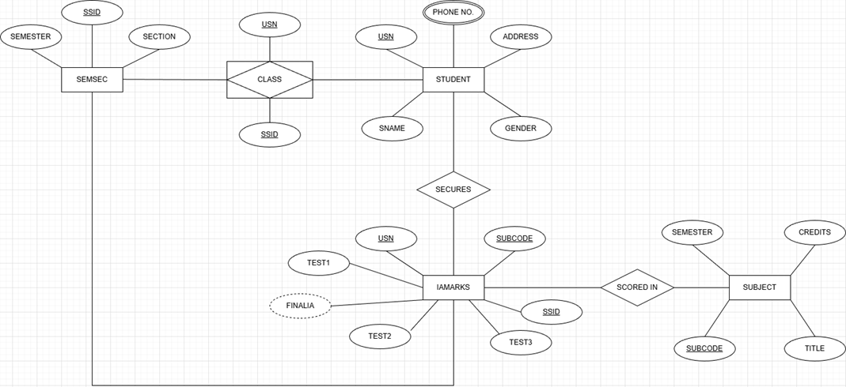
E R diagram:

ENTITIES AND ATTRIBUTES

- SEMSEC
Represents semester and section details.
Attributes:
• SSID (Primary Key)
• SEMESTER
• SECTION

- STUDENT
Represents student information.
Attributes:
• USN (Primary Key)
• SNAME
• GENDER
• PHONE_NO
• ADDRESS

- SUBJECT
Represents subject details offered in a semester.
Attributes:
• SUBCODE (Primary Key)
• TITLE
• SEMESTER
• CREDITS

- IAMARKS
Represents internal assessment marks secured by students in subjects.
Attributes:
• USN (Foreign Key)
• SUBCODE (Foreign Key)
• SSID (Foreign Key)
• TEST1
• TEST2
• TEST3
• FINALIA (Derived Attribute)

- CLASS
Represents a class allotted to students.
Attributes:
• USN
• SSID

- SECURES
Represents the marks secured by a student.
Attributes:
• USN
• SUBCODE

- SCORED_IN
Represents the subject in which marks are scored.
Attributes:
• SUBCODE
• USN

Relationships:

- CLASS
Represents the relationship between SEMSEC and STUDENT.
One SEMSEC can have many STUDENTS, but each STUDENT belongs to one SEMSEC.
Cardinality: 1 : N
- SECURES
Represents the relationship between STUDENT and IAMARKS.
One STUDENT can secure many IAMARKS records.
Each IAMARKS record belongs to one STUDENT.
Cardinality: 1 : N
- SCORED_IN
Represents the relationship between SUBJECT and IAMARKS.
One SUBJECT can have many IAMARKS records.
Each IAMARKS record belongs to one SUBJECT.
Cardinality: 1 : N

Conclusion: This ER diagram clearly explains how students are related to classes, semesters, subjects, and marks. It helps in designing a proper database structure for managing academic records efficiently.

Experiment No.2

Aim:
To design an Entity Relationship (ER) diagram for the Company database and convert it into relational tables.

E R diagram:

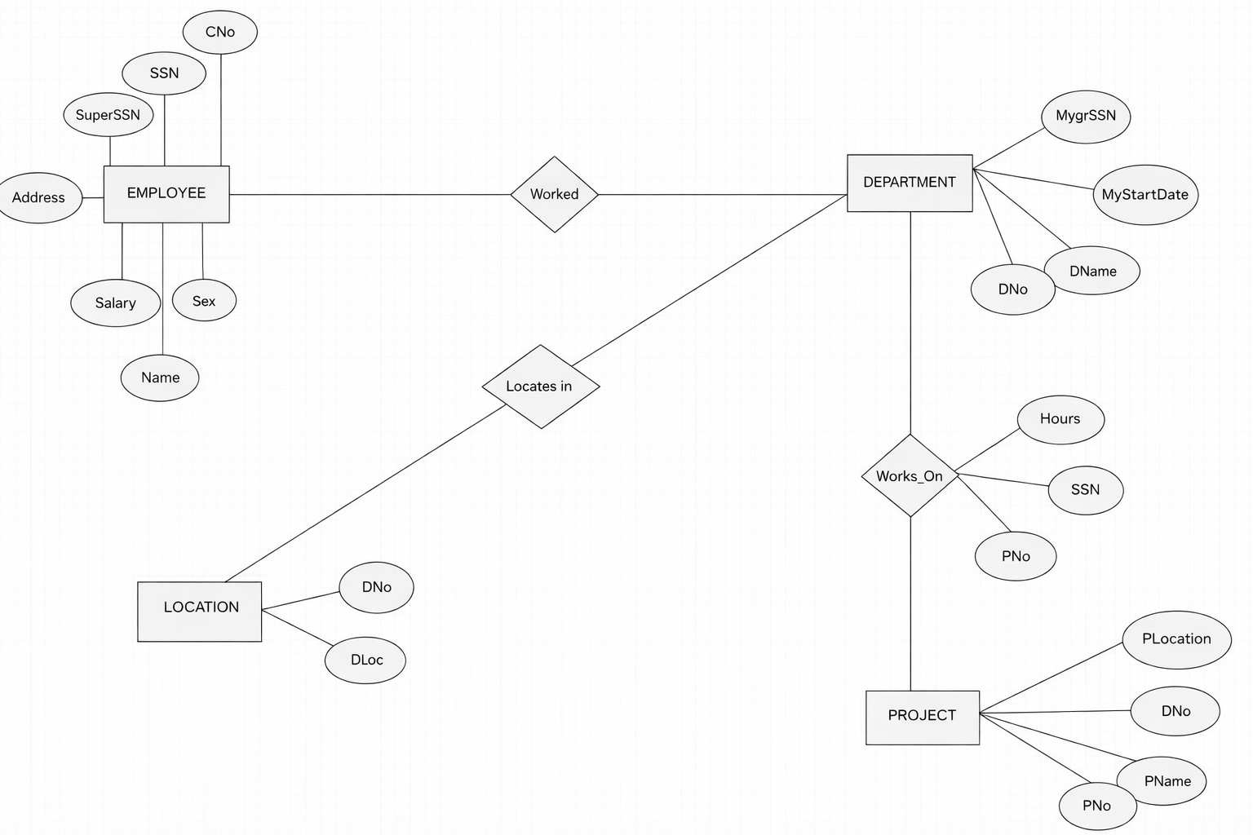

Entities and Attributes:
- EMPLOYEE
Represents an employee working in the organization.
Attributes:
• SSN (Primary Key)
• Name
• Address
• Salary
• Sex
• SuperSSN (Foreign Key)
• DNo (Foreign Key)

- DEPARTMENT
Represents a department in the organization.
Attributes:
• DNo (Primary Key)
• DName
• MgrSSN (Foreign Key)
• MgrStartDate

- LOCATION
Represents the location of a department.
Attributes:
• DNo (Foreign Key)
• DLoc

- PROJECT
Represents projects handled by departments.
Attributes:
• PNo (Primary Key)
• PName
• PLocation
• DNo (Foreign Key)

Relationship:
- EMPLOYEE – DEPARTMENT
Relationship: Worked
An employee works in one department, and a department can have many employees.
Cardinality: 1 : N

- DEPARTMENT – PROJECT
Relationship: Works On
A department controls many projects, and each project is associated with one department.
Cardinality: 1 : N

- EMPLOYEE – PROJECT
Relationship: Works On
An employee can work on multiple projects, and a project can have multiple employees.
The relationship stores the attribute Hours.
Cardinality: M : N

- DEPARTMENT – LOCATION
Relationship: Located In
A department can be located in multiple locations, and each location belongs to one department.
Cardinality: 1 : N

Conclusion:
This ER diagram clearly illustrates the relationships between
employees, departments, projects, and locations in a company. It serves as a strong foundation for designing a well-structured and efficient company database system.

Experiment No.3

Aim:
To design and implement a Customer–Sale database schema using SQL by creating tables with appropriate integrity constraints, inserting records, and performing various queries and views to retrieve bill details, customer purchase information, product sales, and daily sales analysis.

1. Create the tables with the appropriate integrity constraints.

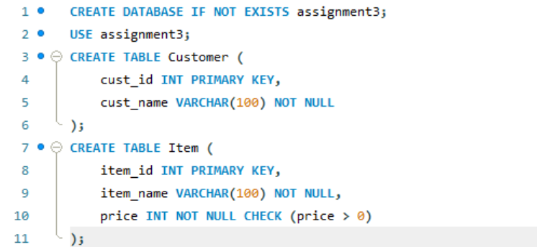

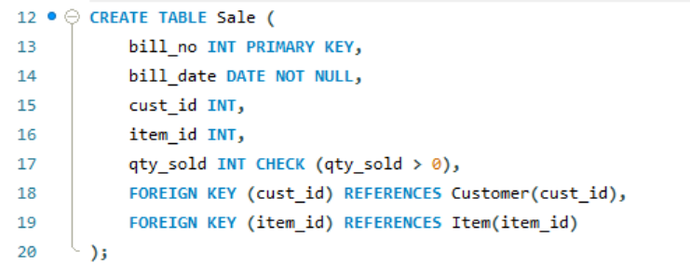

- Insert around 10 records in each of the tables.
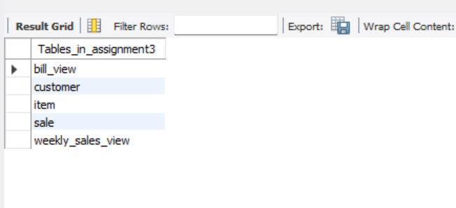
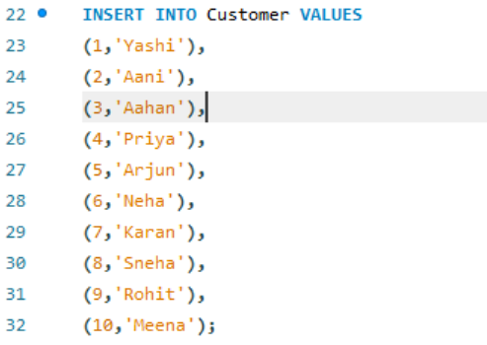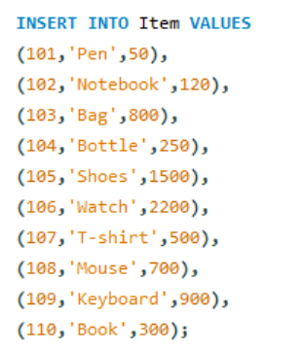
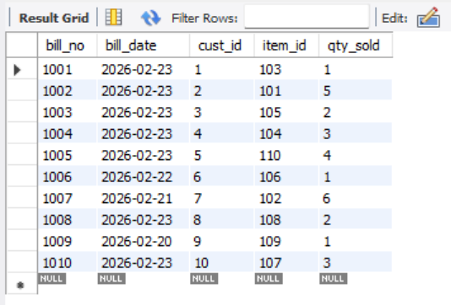
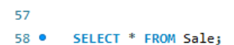
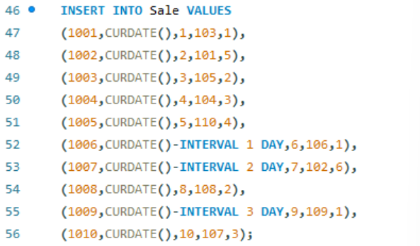

- List all the bills for the current date with the customer names and item numbers.
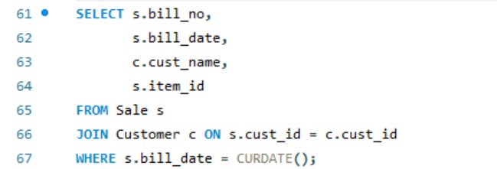

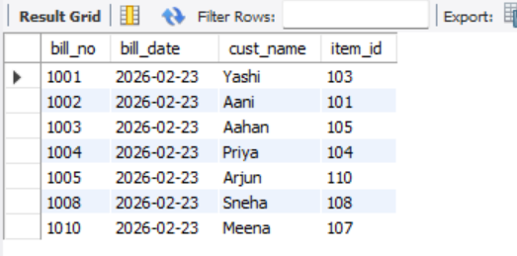

- List the total Bill details with the quantity sold, price of the item and the final amount.
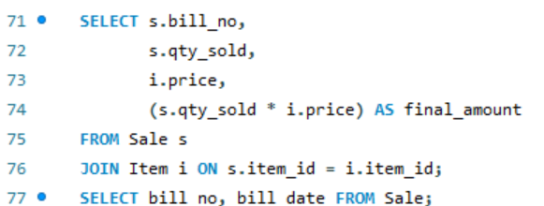

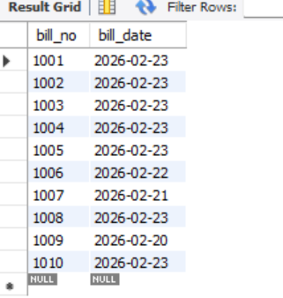

- List the details of the customer who have bought a product which has a price>200.
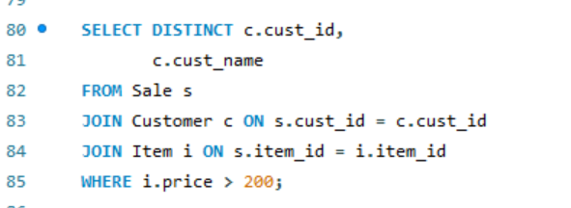

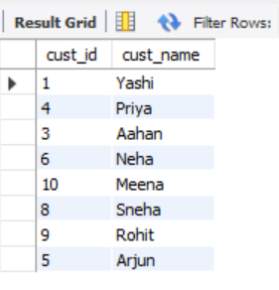

- Give a count of how many products have been bought by each customer.

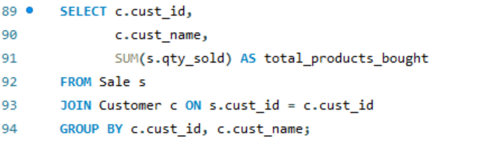

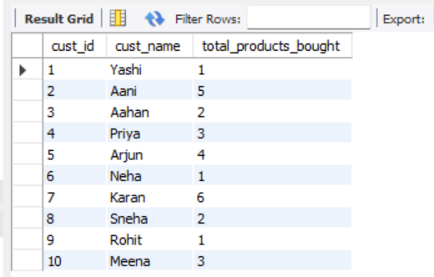

- Give a list of products bought by a customer having cust_id as 5.

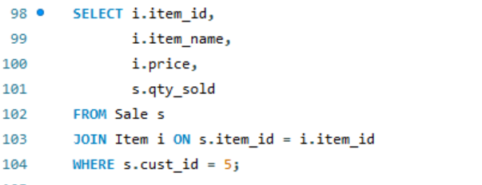

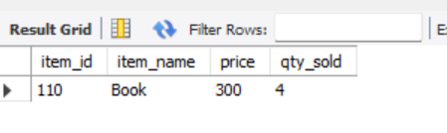
- List the item details which are sold as of today.

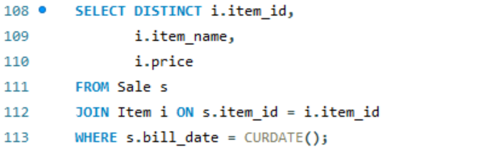
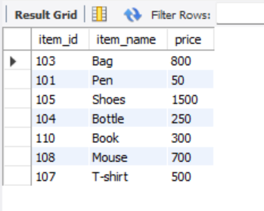

- Create a view which lists out the bill_no, bill_date, cust_id, item_id, price, qty_sold, amount.

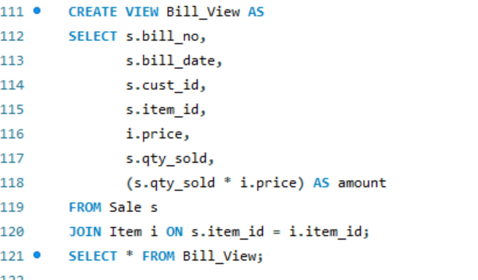

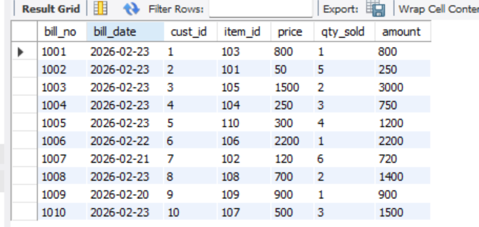

10. Create a view which lists the daily sales date wise for the last one week

